

**Session 4 – Customer App**

**Duration: 120 minutes**

# 1 Instructions

This document contains the special tasks for the 4th session. We advise you to read this document carefully and to get an overview over the provided media like attached images, appendices and text.

The maximum time to complete as many tasks as possible is **120 minutes**. **Within this time** you have to read and understand all tasks and to store the results, **including an APK file** **into the folder** “***Session-4-yourname***” onto the desktop of your computer. The **mobile application should be placed** **on the home screen of the tablet** you will get from the jury because the app will be checked on the device.

This is the fourth session. You are allowed to use all components, source code and windows of this session for the following sessions of the competition. Sometimes it makes sense to use parts of it also for other tasks in the future.

Please for every session create a file containing a short user guide and a technical description of how to configure and start up the application.

Make sure that you follow the provided style guide throughout all parts of the system.

Make sure that you provide appropriate validation and error messages throughout all parts of the system.

Make sure that all relevant buttons/links are working at the end of the session.

Make sure that you use appropriate naming conventions for all parts of the system as needed.

Make sure that your work is on the state of the art of Skill 09.

# 2 Contents

Session 4 of this Test Project consists of the following documentation/files:

1. AEC2024-Skill09-Session 4.pdf
2. Application Structure Session4.pdf
3. Session4.sql

# 3 Project

## 3.1 Introduction

The **Event** **Agency** **NeuBrandenburg** (**EANB**) is a modern enterprise which organizes, manages and offers cultural events in Neubrandenburg and its environment.

This Agency offers their customers an app which can be used to manage personally all interesting events.

## 3.2 The Task

Customers want to manage all events which are for them personally of interest. Therefore two different tasks have to be solved:

A backend server solution has to be implemented which manages the ticket database and which provides the ticket data for a mobile application which also must be written.

The customer has to login with his username (email address) and password at his mobile device and should be able to book tickets using his credit card.

A list of the events will be shown. He selects one, can book tickets and gets them onto his device. Also a calendar view for the events for which he already has booked tickets with links to the event details has to be implemented.

A mechanism to show this ticket if the server connection will be offline should be also implemented.

The customer data and the needed ticket data will be given for this session. Also a short user guide has to be written.

# 4 Application Structure

Three screens are required, and a server API must be written:

The ***Login Screen,*** the ***Event List Screen*** including taps for details, saving and ticket booking***,*** and the ***Calendar Screen***.

# 5 Tasks

## 5.1 Database and Server API

**Quality tested** Database implementation at the backend

**Work requested**

* The database should imported using *Session4.sql* on the server.
* The database structure provided cannot be altered
* Do not remove tables, add or delete any fields on the tables or change their data types
* Refer to the ERD below for the database structure
* The backend should support all operations required by the mobile app
* Refer to the ERD below for the database structure

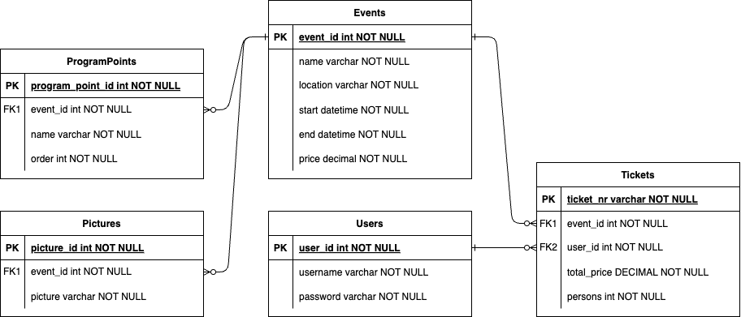

## 5.2 Login Screen

**Quality tested** Programming, UI Design, DB Access

**Mockup**

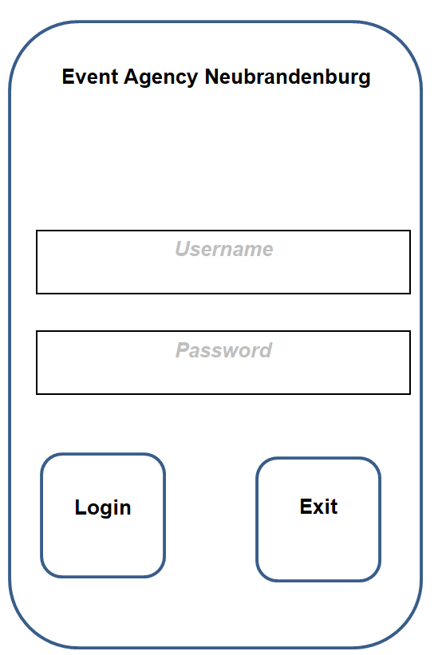

**Work requested** General

* Create the Login Screen.
* The Username is an email address and will be checked against the customer’s table entries.
* Upon a successful attempt, they will be directed to the event list screen (item **5.3**).

## 5.3 Event List Screen

**Quality tested** Programming, UI Design, DB Access

**Mockup** to be useful design

**Work requested** General

* Create the screen.
* The starting screen shows an event list with a filter function. The data is given in the file *events.csv*. The *name, venue* and *start date and time* should be shown. The filtering should be possible for all of these three items.
* By tapping on an event details of this event are to seen: additionally *end date and time, price, program points and pictures* are shown.
* It should be possible to save this event – that means it will be included in the calendar screen.
* To buy a ticket the user should be directed to the ticket screen (item **5.4**)
* A button at the bottom of the screen opens the calendar screen (item **5.5**)

## 5.4 Ticket Screen

**Quality tested** Programming, UI Design, DB Access

**Mockup** must bedesigned

**Work requested** General

* Create the screen.
* Depending on the selection in the ***Event List Screen*** the following data of the selected event should be shown: *name, venue, start date and time, end date and time* and *price.*
* Now it should be possible to order some number of tickets.
* The total price should be calculated and shown then.
* The customer should be able to input his credit card information*: credit card type (Visa Card, Master Card, American Express), credit card number: 16 digits, expiration date: mm/yy, check number: 3 digits*.
* All parts of the credit card information must be validated.
* When pressing the purchase button, the user should be prompted with a confirmation dialog, that asks him if he really wants to complete the purchase.
* After confirming the purchase, the customer will receive a digital ticket with the following information: the ticket number, the event (name, venue, start date, start time, price, number of persons) and it will be shown in a popup.
* The ticket number should be calculated in the following way: *aabbccddeexxxxxx* where *aa, bb, cc, dd, ee* are calculate from the first five letters of the event name. aa representing the position number of the first letter, bb from the second letter etc. (space has the number 0) and *xxxxxx* is a random number of 6 digits (e.g. venue: Albert-Einstein-Gymnasium => 0112020518xxxxxx).
* This ticket will be saved on the device and it should be offline available.
* Pressing the back button the user will be redirected to the event list screen.

## 5.5 Calendar screen

**Quality tested** Programming, UI Design, DB Access

**Mockup**  to be useful design

**Work requested** General

* Create the Screen.
* This screen needs to be available offline.
* The screen shows a typical monthly calendar view with week days and day number.
* All days with planned or booked events should be displayed using different colours.
* The used colours should be explained in a legend.
* By tapping on a marked day, the events on this day are shown with details including the ticket information, if available.
* Pressing the back button the user will be redirected to the event list screen.

## 5.6 Documentation / Notes

**Quality tested** Documentation

**Work requested**

* Please create a file containing a short user guide and a technical description of how to configure, how to get access to your database and start up the application.
* In this file you may also leave *notes* that could be useful for the evaluation. *Notes* in this document are not part of the evaluation process.